- Bluebook Page145 May 2019 variant three examination:

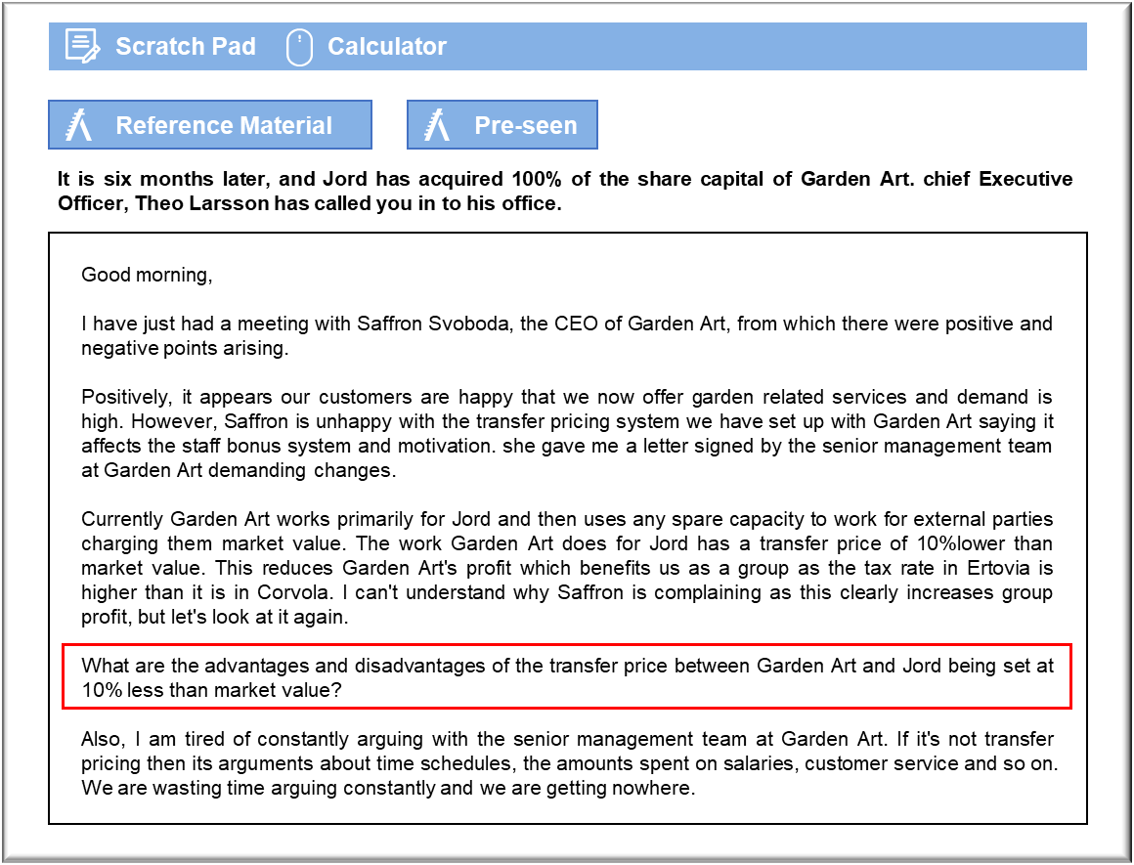

MANAGEMENT CASE STUDY MAY 2019 EXAM ANSWERS

Variant3 Task3
These answers have been provided by CIMA for information purposes only. The answers created are indicative of a response that could be given by a good candidate. They are not to be considered exhaustive, and other appropriate relevant responses would receive credit.

CIMA will not accept challenges to these answers on the basis of academic judgement.

The transfer pricing system we have set up seeks to move profit from Garden Art to
Jord, in order to benefit from a better tax rate in Corvola than Ertovia. In theory, that
would lead to the recognition of more profit in the country with the lower tax rate,
which would benefit Jord as a whole. Such behaviour is, however, unlikely to be
acceptable to the tax authorities in Ertovia. It is very likely that this approach would be
deemed unacceptable from a tax perspective. If Jord went ahead then it could lead to
investigations and demands for additional tax payments in Ertovia.
There have been cases recently in which major multinational corporations have been
accused of trying to artificially reduce their tax bills through manipulation of transfer
prices. That has led to bad publicity for the companies concerned. The directors have
been accused of unethical behaviour and so it has caused reputational damage as well
as penalty payments.
There is nothing to prevent Jord from using this approach for internal management
purposes, with adjustments to reported earnings to cancel the 10% reduction. That
could, however, lead to behavioural consequences and Jord may want to assess
whether the benefit gained by lowering the tax bill, particularly as Garden Art is
currently barely profit making, are worth the potential issues that might be caused
within the group.
Transfer pricing in this way may impact on the morale and motivations of staff at
Garden Art. We know that they have some spare capacity and can still attract work at
market value which at present is more beneficial to staff’s revenue-based bonus system
than performing the 10% discounted work for Jord.
We have already received complaints from Saffron Svoboda, including a letter written
on behalf of the whole management team, stating their annoyance at the transfer
pricing in place. In this instance it appears to have affected their results, reducing the
self-esteem of the team and impacting the bonuses they can achieve. Whether the
bonus system in place is appropriate is a matter for separate consideration but,
certainly, this transfer pricing system has caused disgruntlement at the subsidiary.
The disgruntlement could lead to behaviours that cause problems at Jord. If Garden
Art behave badly on Jord jobs reputation will be affected, and if they continue to fill
their order book with external work, instead of prioritising Jord work, it could
seriously affect the scheduling of jobs and reputation overall. Jord should be able to
enforce upon Garden Art how they schedule Jord work in, but further steps to micro
manage these people could be very badly received causing further problems.
It may be beneficial, at this point, to revisit the transfer pricing system to address the
issues raised by Garden Art, perhaps as part of an exercise to look again at the whole
working relationship between Jord and Garden Art. A dual pricing system where
Garden Art records one price and Jord records another price may lead to some year?end adjustments in the accounts but could potentially keep both parties happy.

Managing conflict
There are significant problems occurring relating to conflict between Jord and Garden
Art. It appears that Jord have attempted to make a start on cost management at
Garden Art and tried to impose Jord ways of working and scheduling, as well as the
previously discussed transfer pricing system.
To some extent, Garden Art should be expected to come into line with Jord. They are
100% owned by Jord and, so, it is not unreasonable for Jord to require Garden Art to
work in certain ways and follow the rules of operation of Jord as a company.
However, they don’t want a ‘riot’ on their hands, so may wish to look for a way to
resolve the conflict more collaboratively, rather than simply laying down rules about
how things should work.
Good communication is always a good start point for such efforts. Explaining to the
team at Garden Art why Jord works in the way it does, and why it is important for good
performance, lays down the basis for discussions about why Jord would now like
Garden Art to work in that way.
Jord may want to emphasise that, ultimately, higher profitability is likely to be
beneficial to everyone at Garden Art and, although it may seem difficult to accept
compromises and changes in the shot-term, the long-term benefits may be quite
positive for staff at Garden Art. Jord could even set up a bonus system for Garden Art
staff based on group profitability. This could lead to more goal congruence across the
organisation.
It would be worth Jord spending some time with the team at Garden Art, talking these
matters through. This would also allow them to identify any members of staff at
Garden Art who could assist with their efforts to tighten things up at Garden Art.
Identifying people who will be a driving force for change, keeping the peace and
working collaboratively, could be very useful to Jord allowing them to work from the
inside to resolve conflicts and achieve improvements overall.

